In [1]:

import numpy as np

import pandas as pd

import matplotlib.pyplot as plt

import seaborn as sns

from sklearn.cluster import KMeans

In [2]:

customer_data=pd.read_csv('Mall_Customers.csv')

In [3]:

customer_data.head()

Out[3]:

|  | **CustomerID** | **Gender** | **Age** | **Annual Income (k$)** | **Spending Score (1-100)** |
| --- | --- | --- | --- | --- | --- |
| **0** | 1 | Male | 19 | 15 | 39 |
| **1** | 2 | Male | 21 | 15 | 81 |
| **2** | 3 | Female | 20 | 16 | 6 |
| **3** | 4 | Female | 23 | 16 | 77 |
| **4** | 5 | Female | 31 | 17 | 40 |

In [4]:

customer_data.shape

Out[4]:

(200, 5)

In [5]:

customer_data.info()

<class 'pandas.core.frame.DataFrame'>

RangeIndex: 200 entries, 0 to 199

Data columns (total 5 columns):

# Column Non-Null Count Dtype

--- ------ -------------- -----

0 CustomerID 200 non-null int64

1 Gender 200 non-null object

2 Age 200 non-null int64

3 Annual Income (k$) 200 non-null int64

4 Spending Score (1-100) 200 non-null int64

dtypes: int64(4), object(1)

memory usage: 7.9+ KB

In [6]:

customer_data.isnull().sum()

Out[6]:

CustomerID 0

Gender 0

Age 0

Annual Income (k$) 0

Spending Score (1-100) 0

dtype: int64

In [7]:

X=customer_data.iloc[:,[3,4]].values

In [8]:

print(X)

[[ 15 39]

[ 15 81]

[ 16 6]

[ 16 77]

[ 17 40]

[ 17 76]

[ 18 6]

[ 18 94]

[ 19 3]

[ 19 72]

[ 19 14]

[ 19 99]

[ 20 15]

[ 20 77]

[ 20 13]

[ 20 79]

[ 21 35]

[ 21 66]

[ 23 29]

[ 23 98]

[ 24 35]

[ 24 73]

[ 25 5]

[ 25 73]

[ 28 14]

[ 28 82]

[ 28 32]

[ 28 61]

[ 29 31]

[ 29 87]

[ 30 4]

[ 30 73]

[ 33 4]

[ 33 92]

[ 33 14]

[ 33 81]

[ 34 17]

[ 34 73]

[ 37 26]

[ 37 75]

[ 38 35]

[ 38 92]

[ 39 36]

[ 39 61]

[ 39 28]

[ 39 65]

[ 40 55]

[ 40 47]

[ 40 42]

[ 40 42]

[ 42 52]

[ 42 60]

[ 43 54]

[ 43 60]

[ 43 45]

[ 43 41]

[ 44 50]

[ 44 46]

[ 46 51]

[ 46 46]

[ 46 56]

[ 46 55]

[ 47 52]

[ 47 59]

[ 48 51]

[ 48 59]

[ 48 50]

[ 48 48]

[ 48 59]

[ 48 47]

[ 49 55]

[ 49 42]

[ 50 49]

[ 50 56]

[ 54 47]

[ 54 54]

[ 54 53]

[ 54 48]

[ 54 52]

[ 54 42]

[ 54 51]

[ 54 55]

[ 54 41]

[ 54 44]

[ 54 57]

[ 54 46]

[ 57 58]

[ 57 55]

[ 58 60]

[ 58 46]

[ 59 55]

[ 59 41]

[ 60 49]

[ 60 40]

[ 60 42]

[ 60 52]

[ 60 47]

[ 60 50]

[ 61 42]

[ 61 49]

[ 62 41]

[ 62 48]

[ 62 59]

[ 62 55]

[ 62 56]

[ 62 42]

[ 63 50]

[ 63 46]

[ 63 43]

[ 63 48]

[ 63 52]

[ 63 54]

[ 64 42]

[ 64 46]

[ 65 48]

[ 65 50]

[ 65 43]

[ 65 59]

[ 67 43]

[ 67 57]

[ 67 56]

[ 67 40]

[ 69 58]

[ 69 91]

[ 70 29]

[ 70 77]

[ 71 35]

[ 71 95]

[ 71 11]

[ 71 75]

[ 71 9]

[ 71 75]

[ 72 34]

[ 72 71]

[ 73 5]

[ 73 88]

[ 73 7]

[ 73 73]

[ 74 10]

[ 74 72]

[ 75 5]

[ 75 93]

[ 76 40]

[ 76 87]

[ 77 12]

[ 77 97]

[ 77 36]

[ 77 74]

[ 78 22]

[ 78 90]

[ 78 17]

[ 78 88]

[ 78 20]

[ 78 76]

[ 78 16]

[ 78 89]

[ 78 1]

[ 78 78]

[ 78 1]

[ 78 73]

[ 79 35]

[ 79 83]

[ 81 5]

[ 81 93]

[ 85 26]

[ 85 75]

[ 86 20]

[ 86 95]

[ 87 27]

[ 87 63]

[ 87 13]

[ 87 75]

[ 87 10]

[ 87 92]

[ 88 13]

[ 88 86]

[ 88 15]

[ 88 69]

[ 93 14]

[ 93 90]

[ 97 32]

[ 97 86]

[ 98 15]

[ 98 88]

[ 99 39]

[ 99 97]

[101 24]

[101 68]

[103 17]

[103 85]

[103 23]

[103 69]

[113 8]

[113 91]

[120 16]

[120 79]

[126 28]

[126 74]

[137 18]

[137 83]]

In [9]:

wcss=[]

for i in range(1,11):

kmeans=KMeans(n_clusters=i, init='k-means++', random_state=42)

kmeans.fit(X)

wcss.append(kmeans.inertia_)

C:\Users\jkong\anaconda3\lib\site-packages\sklearn\cluster\_kmeans.py:881: UserWarning: KMeans is known to have a memory leak on Windows with MKL, when there are less chunks than available threads. You can avoid it by setting the environment variable OMP_NUM_THREADS=1.

warnings.warn(

In [10]:

sns.set()

plt.plot(range(1,11), wcss)

plt.title('The Elbow Point Graph')

plt.xlabel('Number of Clusters')

plt.ylabel('WCSS')

plt.show()

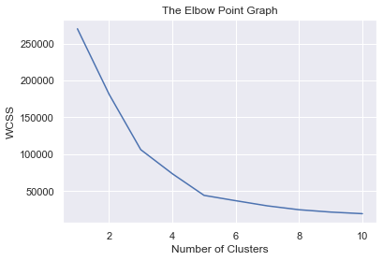

In [13]:

kmeans=KMeans(n_clusters=5, init='k-means++', random_state=0)

Y=kmeans.fit_predict(X)

print(Y)

[4 3 4 3 4 3 4 3 4 3 4 3 4 3 4 3 4 3 4 3 4 3 4 3 4 3 4 3 4 3 4 3 4 3 4 3 4

3 4 3 4 3 4 1 4 3 1 1 1 1 1 1 1 1 1 1 1 1 1 1 1 1 1 1 1 1 1 1 1 1 1 1 1 1

1 1 1 1 1 1 1 1 1 1 1 1 1 1 1 1 1 1 1 1 1 1 1 1 1 1 1 1 1 1 1 1 1 1 1 1 1

1 1 1 1 1 1 1 1 1 1 1 1 2 0 2 1 2 0 2 0 2 1 2 0 2 0 2 0 2 0 2 1 2 0 2 0 2

0 2 0 2 0 2 0 2 0 2 0 2 0 2 0 2 0 2 0 2 0 2 0 2 0 2 0 2 0 2 0 2 0 2 0 2 0

2 0 2 0 2 0 2 0 2 0 2 0 2 0 2]

In [14]:

plt.figure(figsize=(8,8))

plt.scatter(X[Y==0, 0], X[Y==0, 1], s=50, c='green', label='Cluster1')

plt.scatter(X[Y==1, 0], X[Y==1, 1], s=50, c='red', label='Cluster2')

plt.scatter(X[Y==2, 0], X[Y==2, 1], s=50, c='yellow', label='Cluster3')

plt.scatter(X[Y==3, 0], X[Y==3, 1], s=50, c='violet', label='Cluster4')

plt.scatter(X[Y==4, 0], X[Y==4, 1], s=50, c='blue', label='Cluster5')

plt.scatter(kmeans.cluster_centers_[:,0], kmeans.cluster_centers_[:,1], s=100, c='cyan', label='Centroids')

plt.title('Customer Groups')

plt.xlabel('Annual Income')

plt.ylabel('Spending Score')

plt.show()

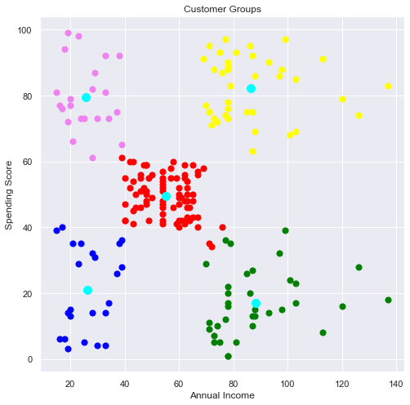

In [ ]: